Production Model Design Report

S2019

|  |  |  |  |
| --- | --- | --- | --- |
| Lab Section: | 1 | Group: | 17 |

# Team Members

|  |  |  |
| --- | --- | --- |
| # | Name | Role |
| 1 | Andy Jin | Software, prototyping and integration testing |
| 2 | Kelly Tang | Schematic, layout and PCB bring-up |

# Design Overview

## Problem Statement

Resistance can be measured a variety of different ways, but the setup is often tedious without the proper equipment and there is a lot of room for error. Design a resistance sensing device that utilizes analog voltage sensing and has notable features such as auto-ranging and user-friendly display to solve this problem.

## Design Scope

The project solves the problem by using a simple voltage divider in conjunction with the MSP430’s on-board ADC to measure voltage across the unknown resistance and compare the results with a known reference resistor. The reference resistor is selectable to give the device the auto-ranging functionality and the measured resistance is displayed to the user on the LCD display.

It was assumed that the device will operate in ideal weather conditions and the object to measure is of a reasonable size (i.e. it is able to fit between the resistance sensing nodes).

## Project Design Requirements

1. The system must be able to successfully determine the resistance of an unknown object within a 10% degree of precision and accuracy
2. The system must relay information in a clear and concise format to the user
3. The system must be able to automatically adjust its resistance range according to provided object
4. The latency between connecting probes to the object and the output of the information to the user must be less than 0.1s

## System-Level Design (High-Level)

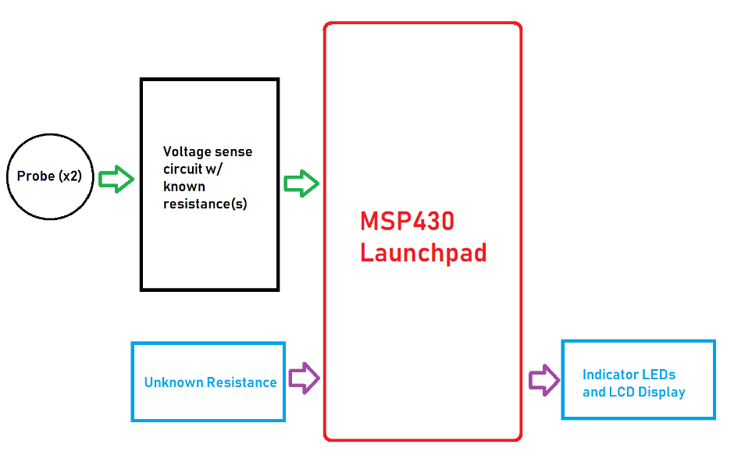

Figure : Updated Resistance Sensor High Level Block Diagram

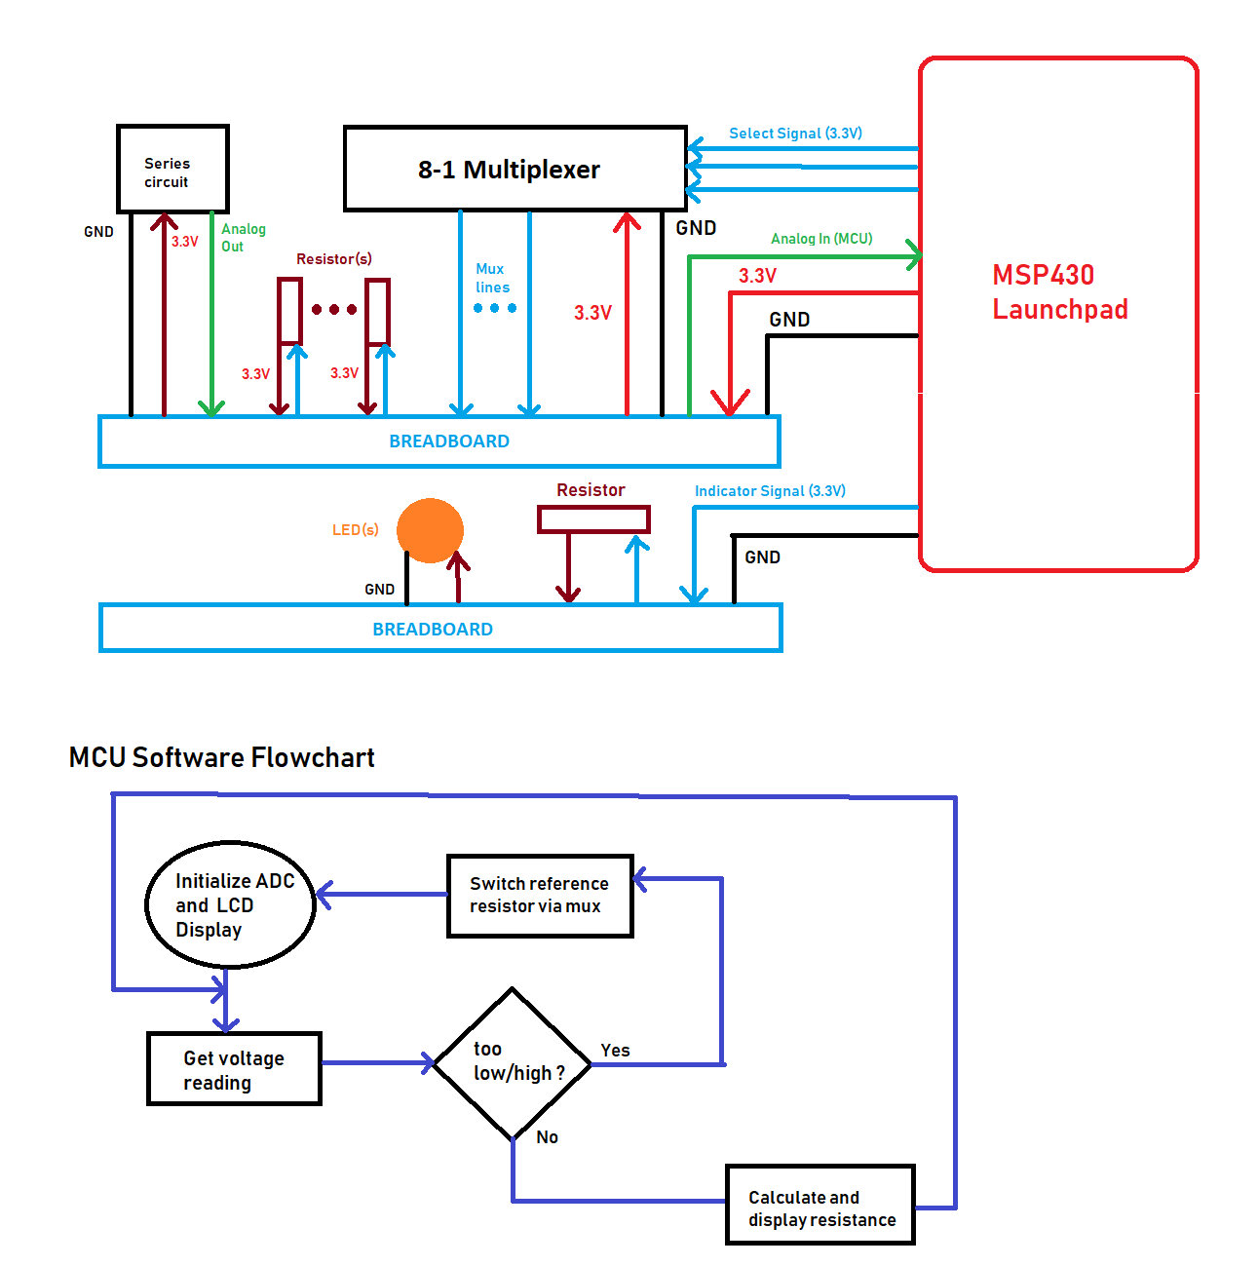

Figure : Updated Feasibility Model Design and a Software Flowchart

## Completed Prototype

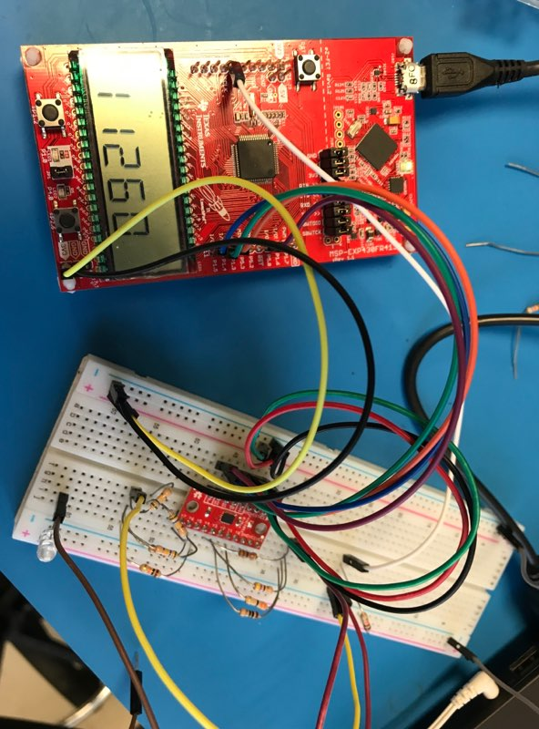 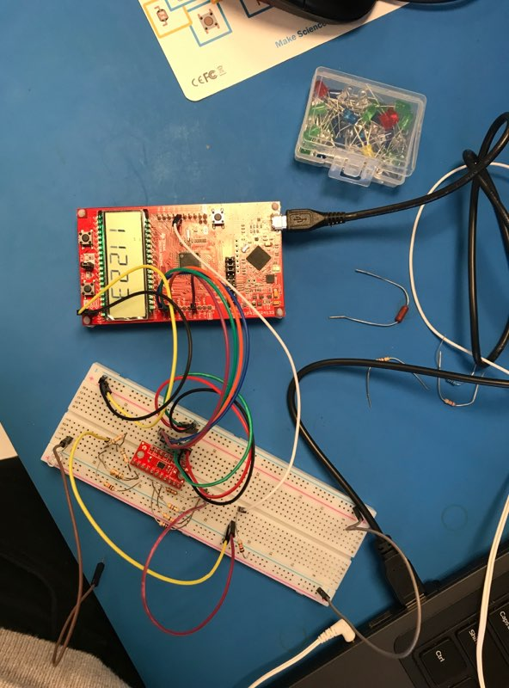

Figure 3 and 4: Initial Prototype for the resistance sensor utilizing the 8-to-1 mux and the LCD display

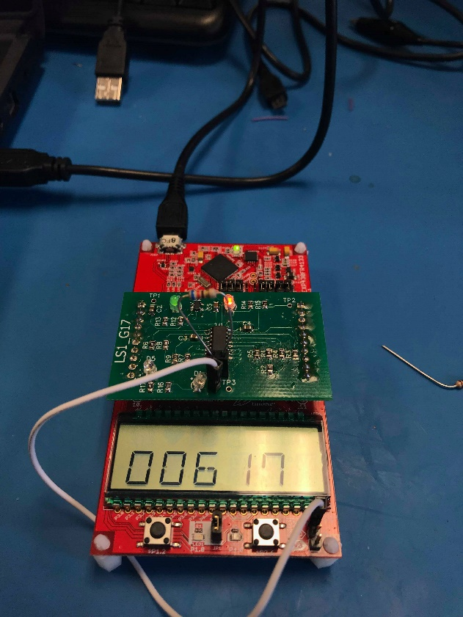

Figure 5 and 6: PCB displaying the resistance of the through-hole resistor with and without indicator LED

## Preliminary Production Design Changes

We had to manually short the indicator LED for the ADC connection as it interfered with the resistance calculations by adding an additional resistance. Also considering adding some form of buffer to the input of the ADC as we are seeing inaccurate values for high resistance values although the voltage drop is consistent. We are assuming this is due to the low-impedance input on the ADC pin which causes a parallel with our resistance and for high value resistances, this would greatly affect our expected voltage drop.

# Member 1 Production Details

Andy Jin – ID# 20712899

## Design for Test (DfT)

Designing for test (DfT) is a design technique in which the designer/engineer adds testability features for both hardware and software aspects of the project. Adding these testability features makes it easier to verify certain components of the project and helps with the debugging process in the case something is malfunctioning. DfT also makes it easier to design and deploy manufacturing tests and is a way of looking forward into the products lifecycle to make life easier for the engineer in the future.

In our project, we split were able to isolate our hardware into 2 major components which we could test individually and designed our software around individually testing the functionality of the hardware components. We used DfT principals when adding hardware test-points to our PCB schematic and layout in addition to adding numerous indicator LEDs to make it easier to identify what was wrong (e.g. connection issues or software issues).

It should be noted that our device runs 3V3 across the unknown resistance that it is measuring so it should be noted that the device that is placed in between the probes should be able to withstand this voltage. Additionally, it should also be noted by the production engineer that because the device is a measuring device, it is very sensitive to hardware connection issues and external environment factors such as temperature. The results of the resistance sensor will behave differently if there is a connection issue and a common one is if there is a problem with the probe connection.

## Energy Efficiency

Energy efficiency is the concept of using less electricity/energy to provide the same service. It is an important goal of many electrical products and systems as it may extend the products lifetime or lowers the cost of use of the product which ultimately results in a more desirable product. With the increased movement towards environmental friendliness, energy efficiency in products is becoming an increasingly desirable trait to consumers.

Our project is fairly energy efficient but there are numerous aspects in which we can improve upon. For one, when there is no connection (i.e. no unknown resistance between the probes) we are still outputting 3V3 which is a huge waste of energy as when the device is idle it should be in its low-power mode. Additionally, because we leave the probes floating, the value measured on the ADC is constantly fluctuating and may cause the mux to switch reference resistors many times which also wastes a lot of energy. Despite this, we are still relatively energy efficient as our voltage divider circuit is fairly simple and does not consume a lot of energy in the first place. We are also able to achieve a fair amount of accuracy with the 3V3 which means that we don’t need an external power source and the low-voltage is sufficient.

It should be noted that in regards to energy efficiency, the device should not be plugged in while not in use because we currently do not have a low-power mode implemented. Also leaving a resistor plugged in to the probes for a long period of time is also not ideal as it is constantly consuming energy. For production purposes, until the low-power mode is implemented via software, stress testing of numerous units at a time is not advised.

# Member 2 Production Details

Jiaming Tang – ID# 20716244

## Design for Manufacturability (DfM)

DFM is the process of designing a product that’s easy to manufacture and is cost-effective. DFM optimizes manufacturing functions such as fabrication, assembly, test, and procurement. If done well, DFM ensures that the product meets quality, cost, and turnaround time expectations.

To design our system using DFM, we wanted to make sure our PCB layout meets fabrication design rules, uses standard components, and is simple enough to assemble. We used trace widths of at least 0.2mm and spaced our traces apart by at least 0.3mm, to ensure that the PCB manufacturing company is able to fabricate our design without any trouble, time-delay, or extra costs. We also used standard components by only using components and modules listed in the course requirements. Those components are widely used and easily accessible. Finally, we made our PCB so that it’s easy to assemble. A board that’s too complex or crowded with components mean that it’s harder to sort through components and look at the design to figure out where to place each component.

Steps for the production engineer that will take our prototype through to a production-ready product include:

* Perform DFM analysis to identify and fix issues. DFM software can identify design issues that could have severe consequences on PCB fabrication (e.g. acid traps, insufficient annular rings, missing solder mask between pads).
* Testing the design to ensure that it complies with safety and quality standards. For example, does our board get too hot during use?
* Determining the manufacturing process, such as considering the quantity of parts being made, who will fabricate the PCBs, etc.

## RoHS

RoHS (Restriction of Hazardous Substances) restricts the use of specific materials found in electrical and electronic products due to their hazardous effects on the environment. The six restricted substances include lead, mercury, cadmium, hexavalent chromium, polybrominated biphenyls, and polybrominated diphenyl ethers. These substances are dangerous to be exposed to, both during manufacturing and disposal. The goal of RoHS is to reduce the environmental and health impacts of electronics.

This topic relates to our project because there is lead in the solder we use, which is substance restricted by the RoHS. We use the traditional lead solder since it’s widely used and requires a lower melting temperature than lead-free solder. However, if we throw away components or boards that we soldered, we’re contributing to the electronic waste that can contaminates the environment with hazardous chemicals.

Steps and considerations for the production engineer that will take our prototype through to a production-ready product include:

* Determining if our PCB design and manufacturing process is RoHS compliant. The production engineer should consider hiring a PCB manufacturer that makes lead-free PCBs, and follows RoHS requirements.
* If lead-free PCB manufacturing is selected, the engineer should compare the cost, board performance, and shelf-life of the lead-free PCB to a PCB that contains lead.
* Determine if there are ways to safely dispose of the PCB and any materials used in the manufacturing/assembly process. The engineer should check if any parts of the PCB (e.g. the copper) can be recycled, and be aware of procedures for chemical waste disposal of hazardous substances.

# References

|  |  |
| --- | --- |
| [1] | "IEEE Style," 2019. [Online]. Available: https://pitt.libguides.com/citationhelp/ieee. |

# Appendix – Detailed Design

Table 1: Necessary Design Changes

|  |  |  |
| --- | --- | --- |
| # | Change | Reason/Notes |
| 1 | Update resistor values for multiplexer | There were some discontinuities in values we can measure with the old resistors |
| 2 | Connect Z input within multiplexer to 3.3V | Some misunderstandings on how the multiplexer functions resulted in incorrect connection of the Z output |
| 3 | Averaged the ADC values to reduce noise | The values of the ADC were changing too frequently due to noise |

Table 2: Important Notes

|  |  |
| --- | --- |
| # | Note |
| 1 | The enable pin on the multiplexer is active low |
| 2 | The resistance sensing circuit is more accurate if the reference resistor is higher than the unknown resistance |
| 3 | The ADC internal reference voltage can be adjusted to be 3.3V or 1.5V |

Table 3: Hardware Signal Test Plan

|  |  |  |  |  |  |
| --- | --- | --- | --- | --- | --- |
| Signal (TP*) | Property | Required Software Mode | Min | Nominal | Max |
| Mux Enable | Voltage | Setup | 0 V |  | 3.3 V |
| Mux Select 0 | Voltage | Switching resistances | 0 V |  | 3.3 V |
| Mux Select 1 | Voltage | Switching resistances | 0 V |  | 3.3 V |
| Mux Select 2 | Voltage | Switching resistances | 0 V |  | 3.3 V |
| ADC In (*) | Voltage | Connecting new resistance | 0 V |  | 3.3 V |

*Indicates Test Point Required

Table 4: Hardware Signal Connectivity

|  |  |  |  |
| --- | --- | --- | --- |
| Signal | MSP430FR4133 Pin | LaunchPad J1/J2 Pin | Prototype Connection |
| Analog In | P8.0 (A8) | J2 pin 6 | Unknown resistor |
| Analog Out | P5.0 | J3 pin 4 | Mux Enable |
| Analog Out | P1.3 | J3 pin 8 | Mux Select 0 |
| Analog Out | P1.4 | J3 pin 9 | Mux Select 1 |
| Analog Out | P1.5 | J3 pin 10 | Mux Select 2 |

Repository: <https://github.com/andyjiin/msp430-resistance-sensor>

